For this assignment students will describe the progress and status of their projects. This will be done by detailing the progress made up to this point, what is currently being worked on, as well as providing a roadmap for what is left to be done to the best of their ability. Students should provide this information in the form of lists (screenshots or copy/pastes of project management software backlog items). In addition, students should provide a link to their repo as evidence of progress.
- Repo link/GitHub (6 points):
https://github.com/NWMSU-Group-Six/Conference-WebApp
- List what has been done up to this point (15 points for at least 10 items).

  - Project Architecture Design and technology stack research
  - Website Diagram Design
  - Create Home Page
  - Create Schedule Page
  - Create Login Page
  - Create Speaker Page
  - Create Sponsor Page
  - Create Submission Page
  - Create Call for Papers Page
  - Create Navbar and Footer
  - Create Committee Page
  - Install and connect Firebase to WebApp
  - Create function to get data from firebase based off collection name
  - Create data models for user data, schedule, speaker, committee, general info
  - Create Sign Up Page
  - Create Registration Page

- List what is currently being worked on or is part of the current sprint (8 points for at least 5 items).

  - Create FAQ Page
  - Registration/Login Logic – connect to authentication app in Firebase
  - Submission logic—connect to database in Firebase
  - Tie authentication user in Firebase to a user document in Firestore
  - Mobile Responsiveness Implementation
  - CSS Standardization
- Provide a comprehensive list of what is left to be done before the project is finished. (15 points for at least 10 items with no redundancies)
  - FAQ and Registration Data models
  - Paper submission model (and hooking it up to the submission page)
  - Admin Dashboard Frontend
  - Admin Dashboard Backend
  - Announcement System
  - Reusable Component Refactor
  - Maintain user session persistence after login
  - Review Dashboard Frontend
  - Review Dashboard Backend
  - Registration Payment Logic
- Use a Gantt Chart to show the completed work and remaining work to be completed. (6 points, A visual chart is required)
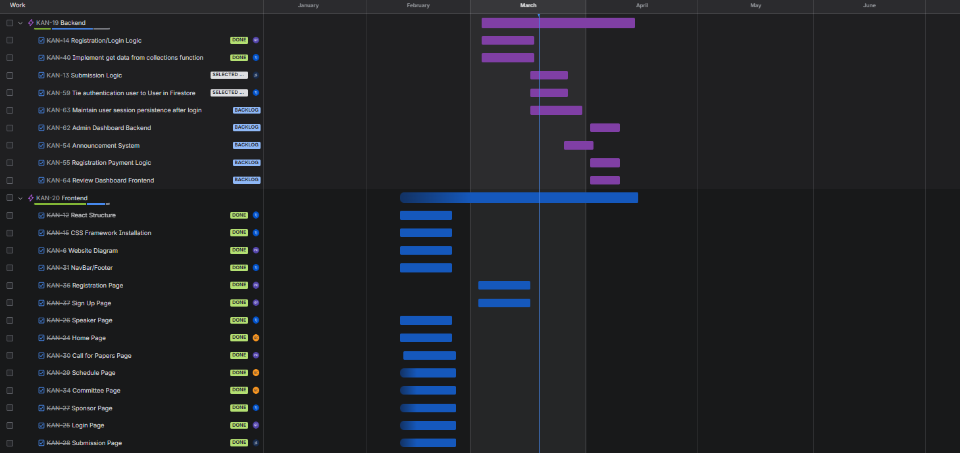
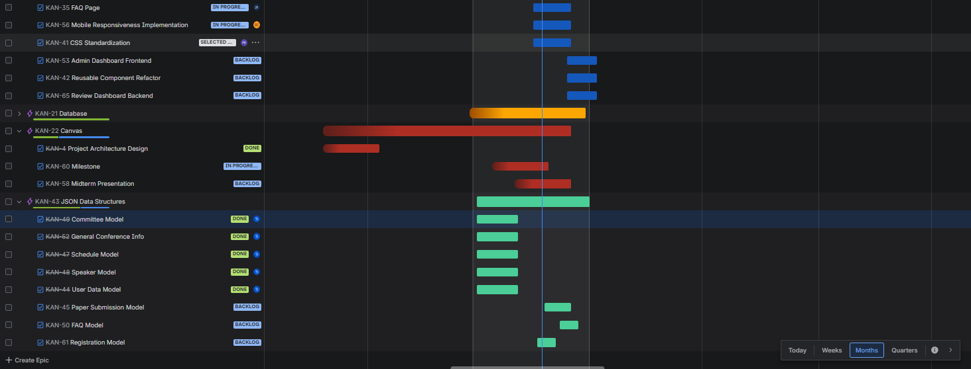
NOTE: Submit word document of your own.

